Sudo

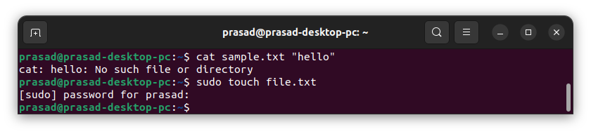

ls

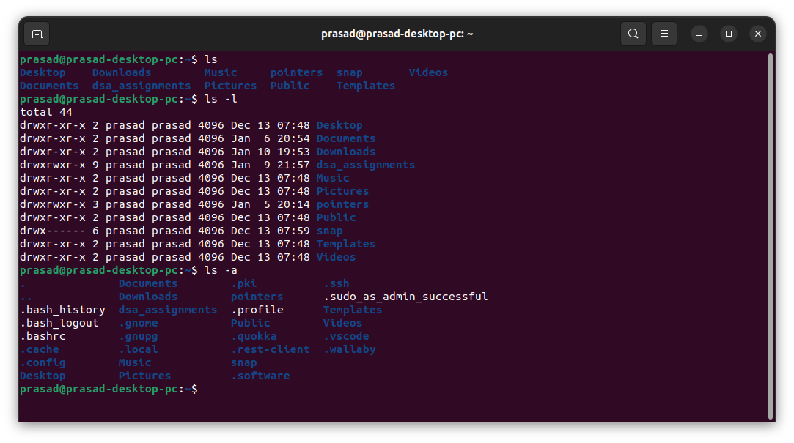

Chmod

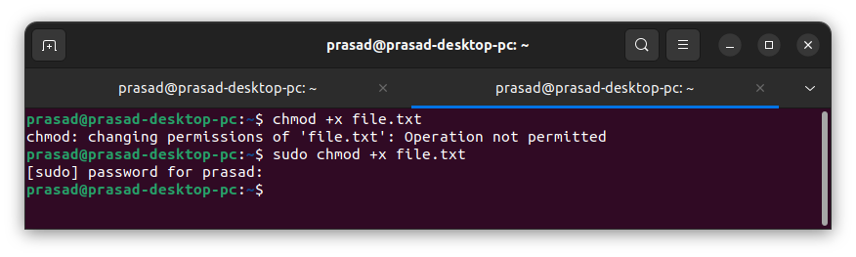

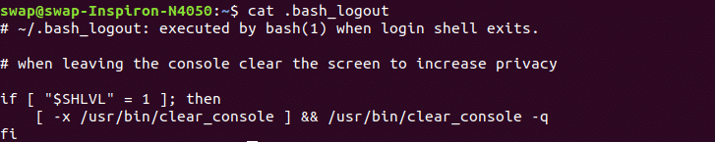 **Cat (Concatenate)**

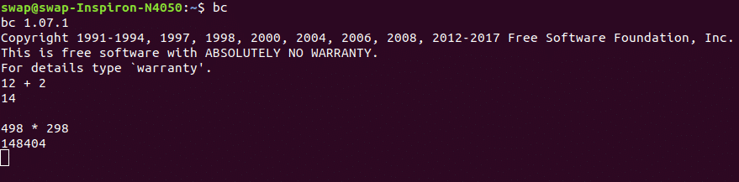**bc**

**chage**

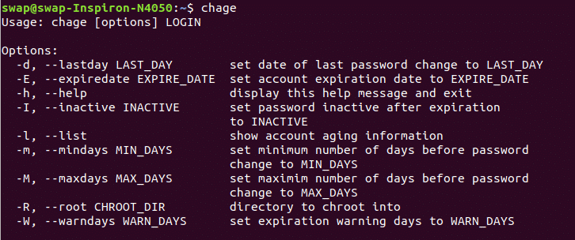

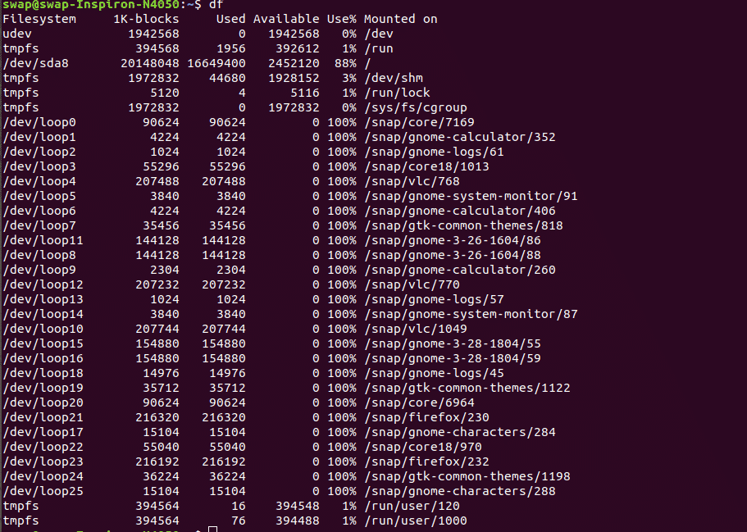 **df**

**help**

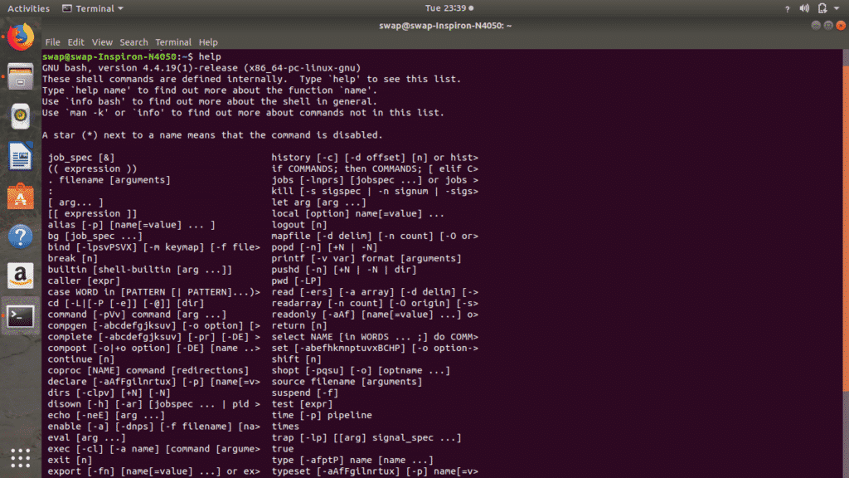

**. pwd**

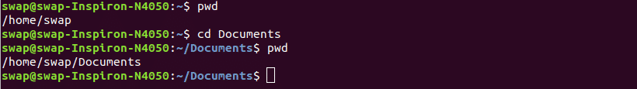 **ls**

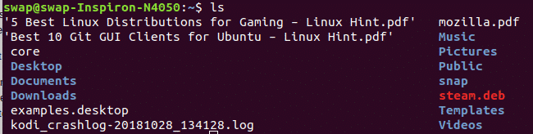

**factor**

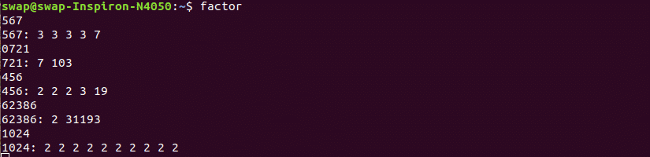 **uname**

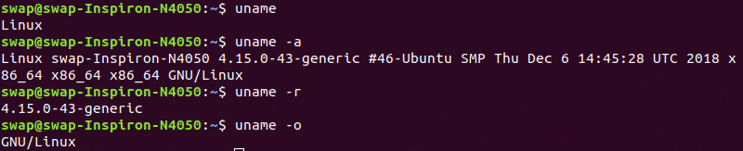

**ping**

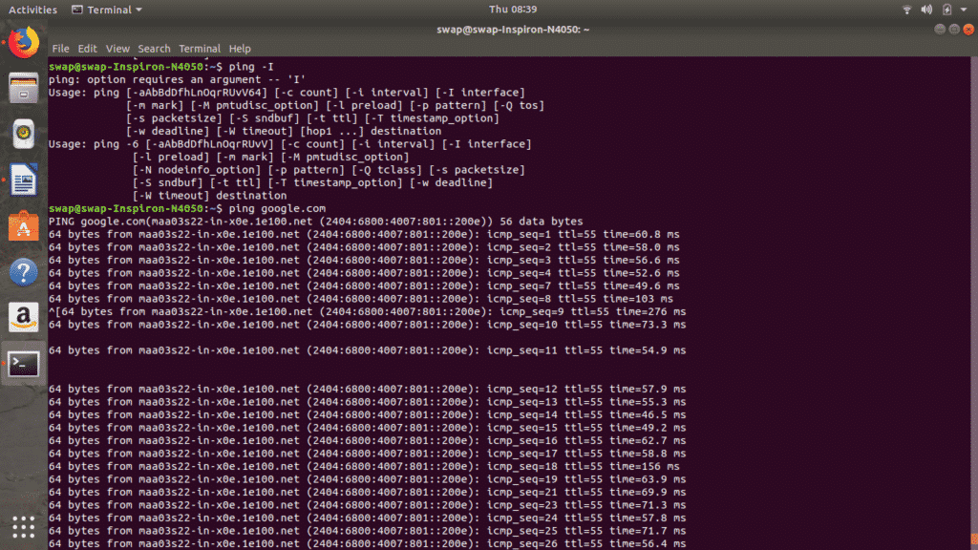 **mkdir**

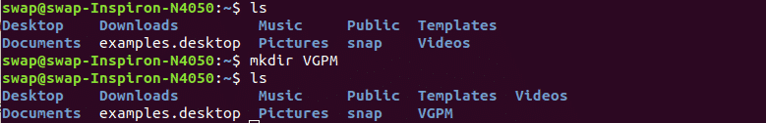**gzip**

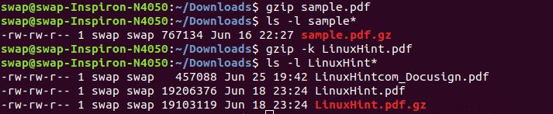 **whatis**

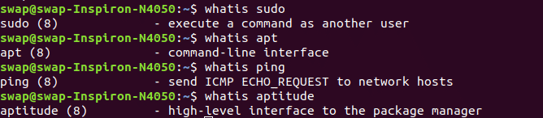

**who**

**https://linuxhint.com/wp-content/uploads/2019/07/who.png free**.

**top**

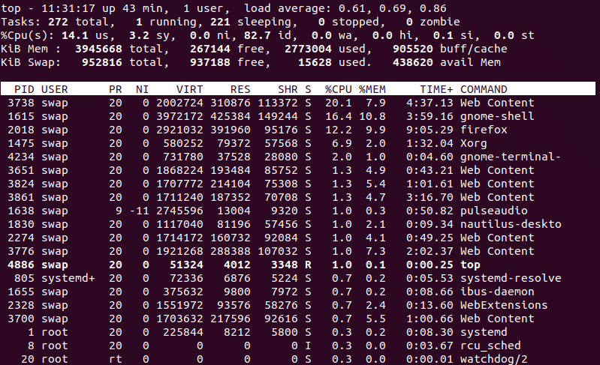

**echo**

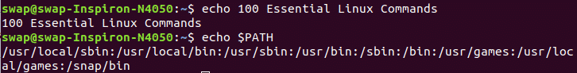 **finger**

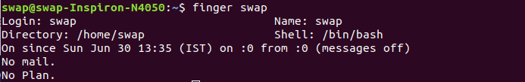

**groups**

**https://linuxhint.com/wp-content/uploads/2019/07/groups.png head**

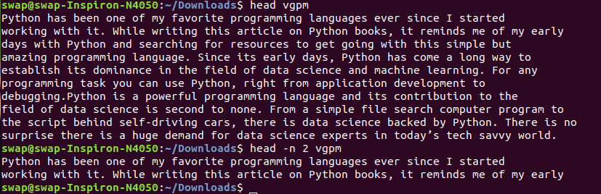 **man**

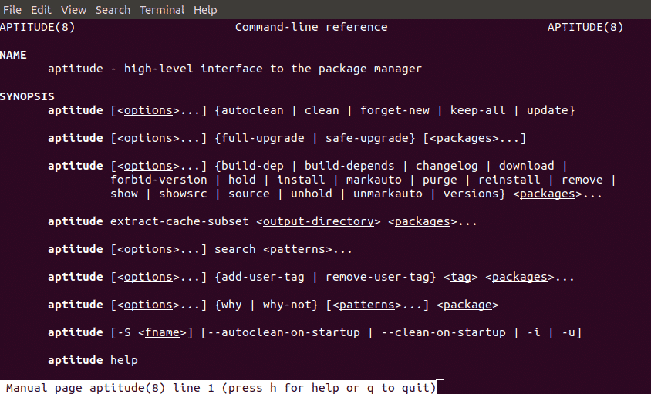 **passwd**

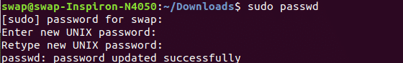

**w**

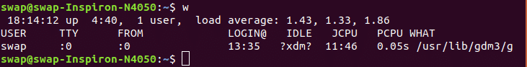 **whoami**.

**https://linuxhint.com/wp-content/uploads/2019/07/whoami.png history**

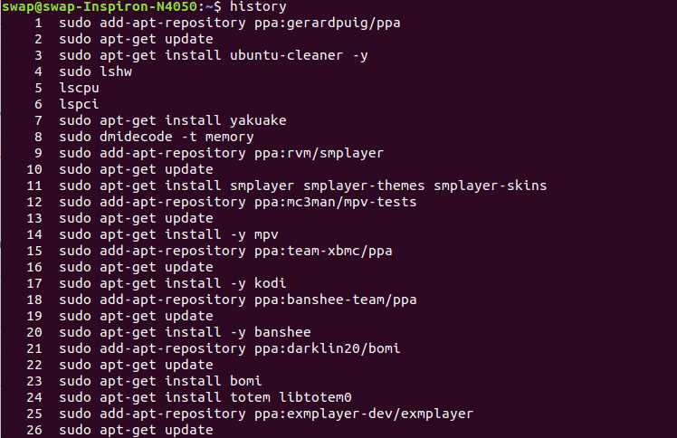

**login**

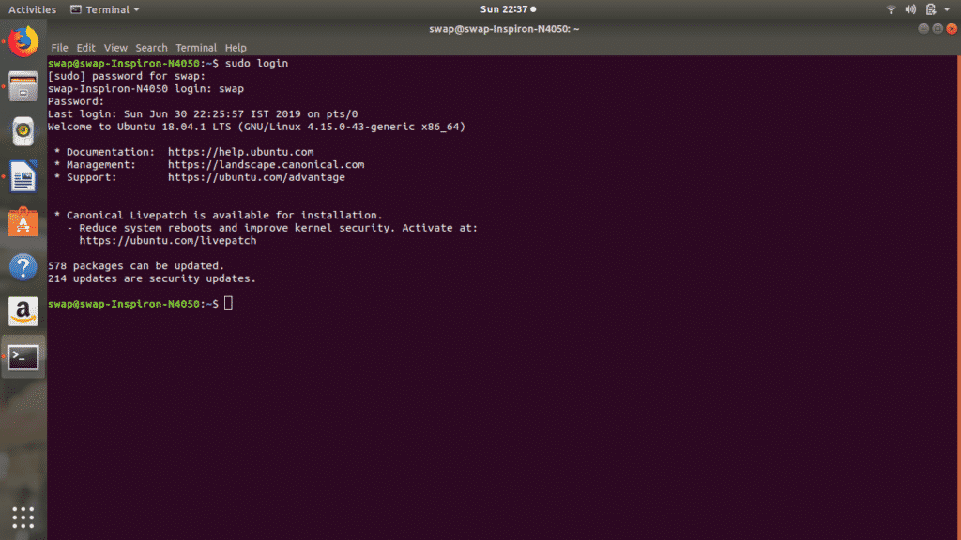

**lscpu**

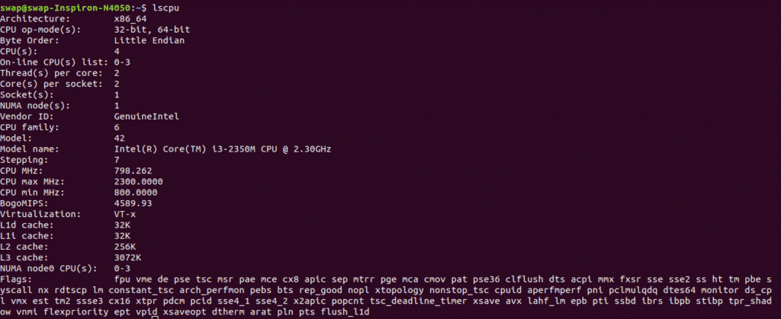 **mv**.

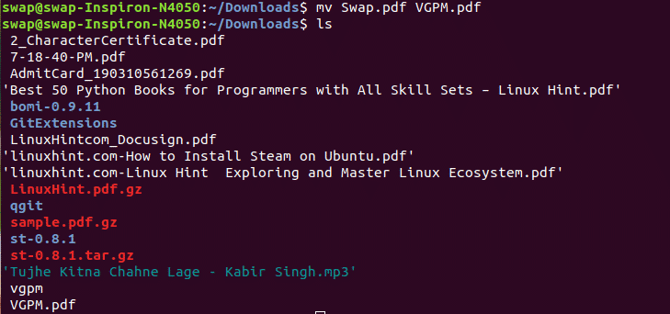

**ps**

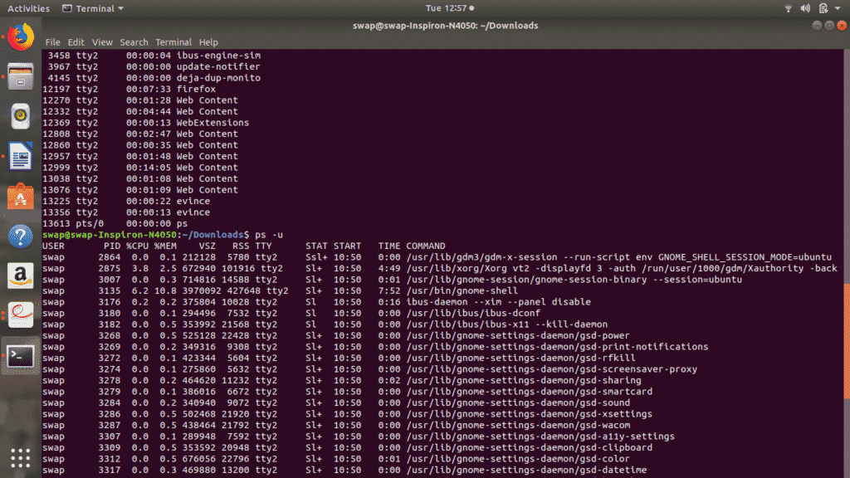

**kill**

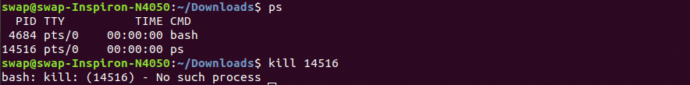**. tail**

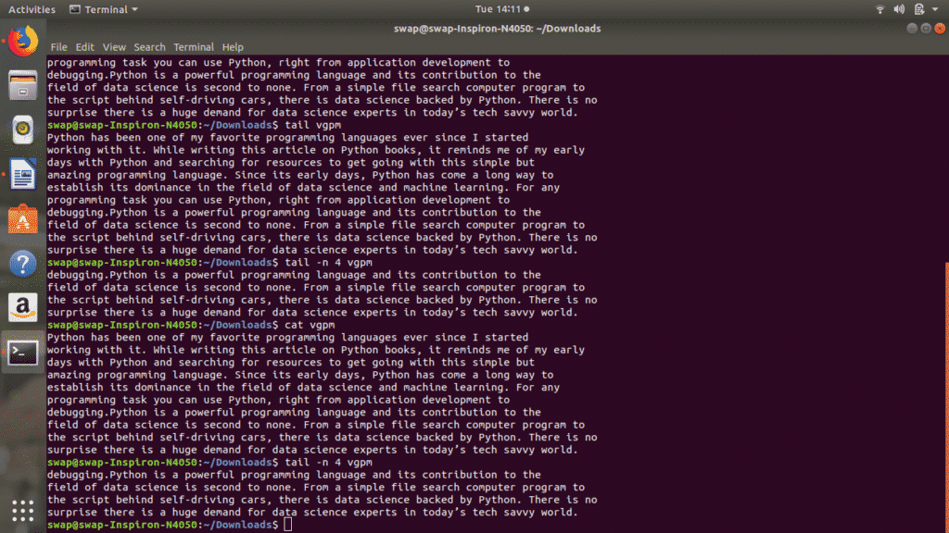**. cksum**

**https://linuxhint.com/wp-content/uploads/2019/07/cksum.png cmp**

** env**

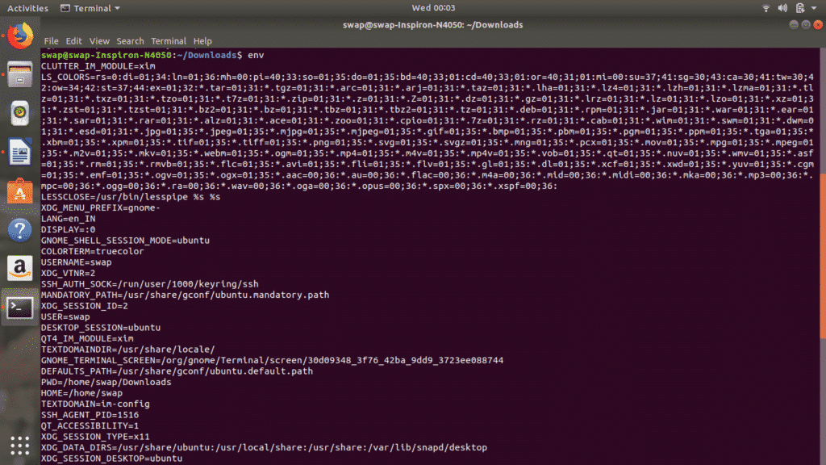

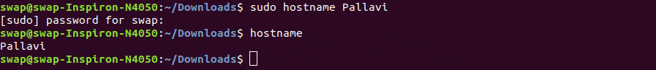**hostname**

**nano**

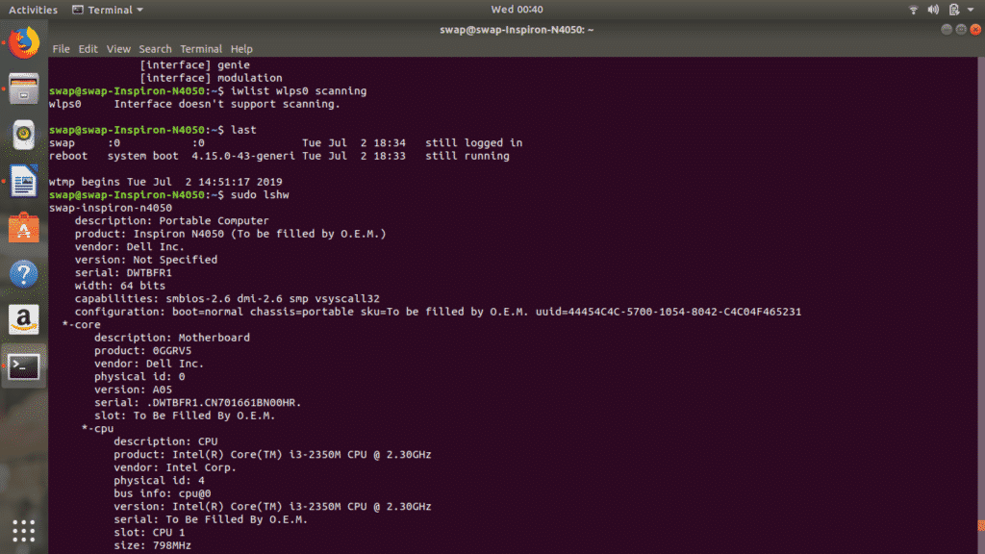

**rm**

